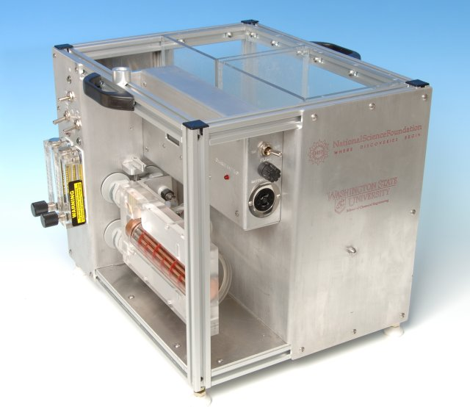

*Figure 1.* Second generation Desktop Learning Module (DLM) with inserted shell and tube heat exchanger cartridge