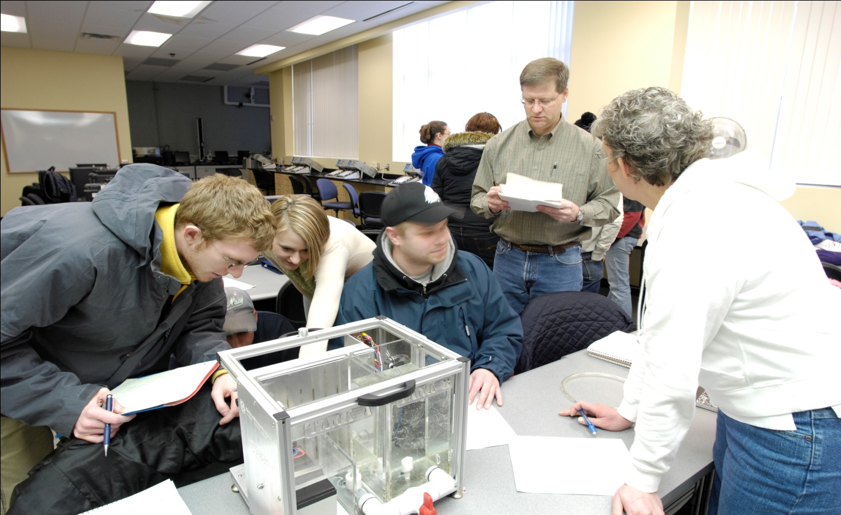

*Figure 2.* Typical CHAPL classroom, with students gathered around a DLM while the instructor observes and interjects where needed to guide or correct the students’ understanding.