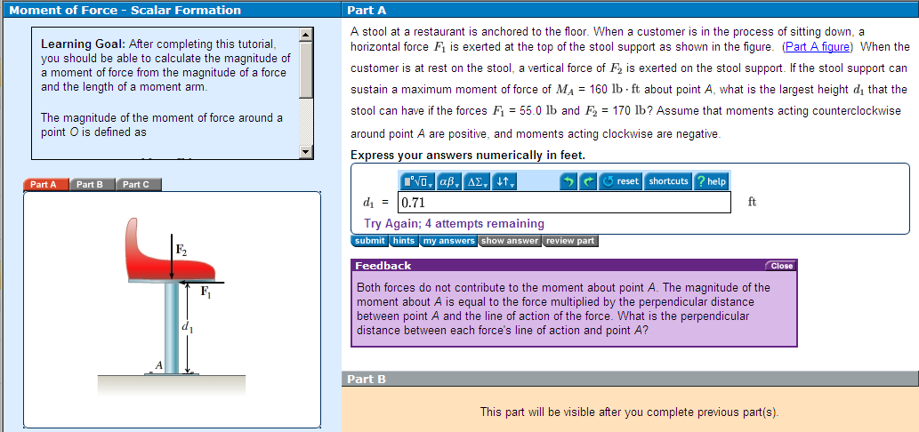

Figure 1. Sample problem from MasteringEngineering.

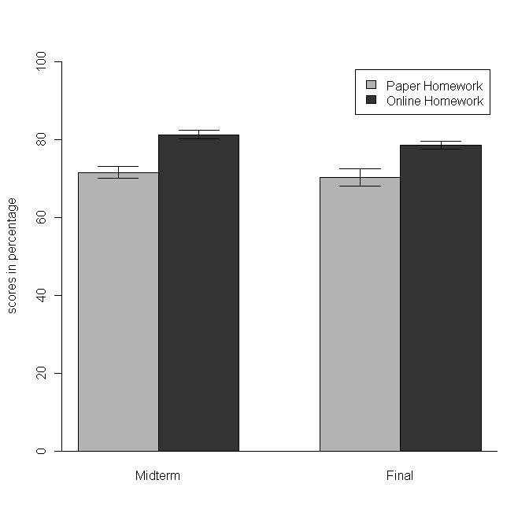
Figure 2. The mean scores of each exam with standard errors in academic years of 2008 (Paper Homework) and 2009 (Online Homework) for the Statics course.

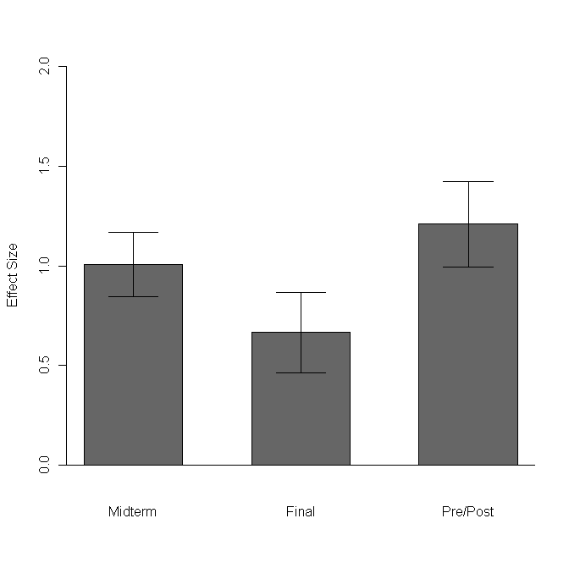
Figure 3. The values of Effect Size with standard errors for each test between Paper Homework and Online Homework for the Statics course. The positive value of Effect Size indicates the improvement affected by using an online homework system. The effect size of 0 means that there is no difference between Paper Homework and Online Homework, that is, no positive effect of using the online homework system.

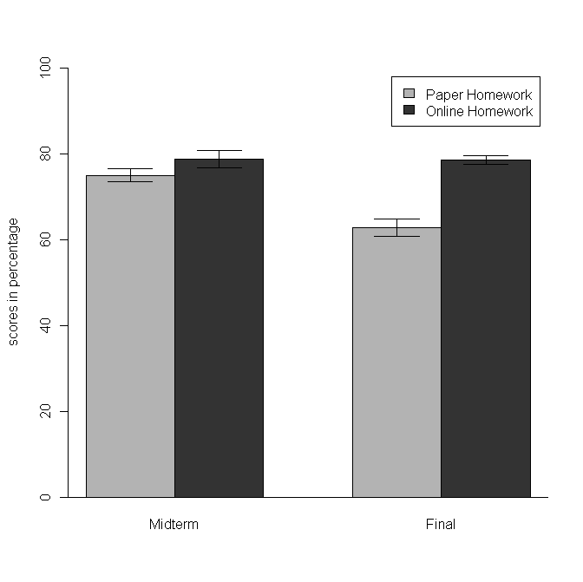
Figure 4. The mean scores of each exam with standard errors in academic years of 2009 (Paper Homework) and 2010 (Online Homework) for the Mechanics of Material course.

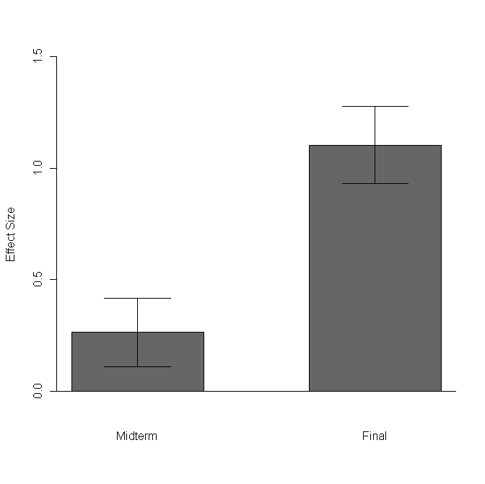
Figure 5. The values of Effect Size with standard errors for each test between Paper Homework and Online Homework for the Mechanics of Material course. The positive value of effect size indicates the improvement affected by using an online homework system. The effect size of 0 means that there is no difference between Paper Homework and Online Homework, that is, no positive effect of using the online homework system.

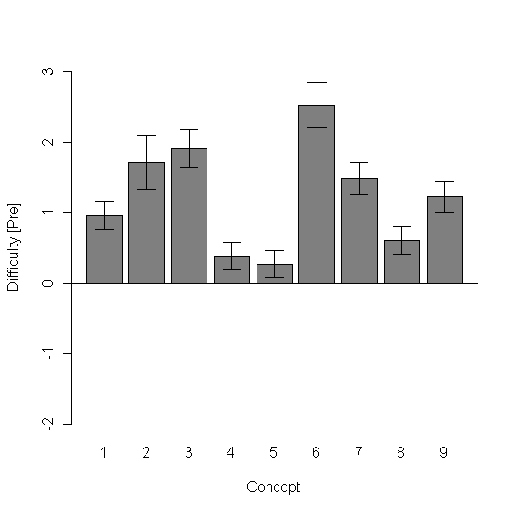
Figure 6. Concept difficulties at the pretest stage.

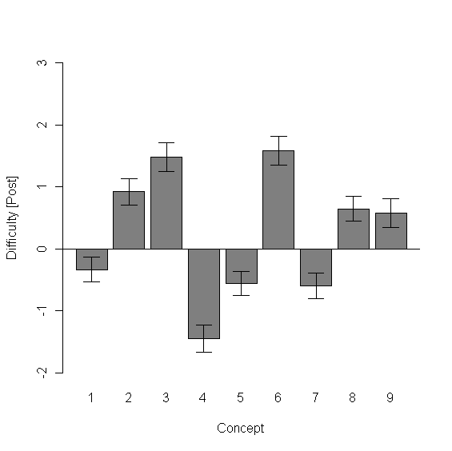
Figure 7. Concept difficulties at the post test stage.

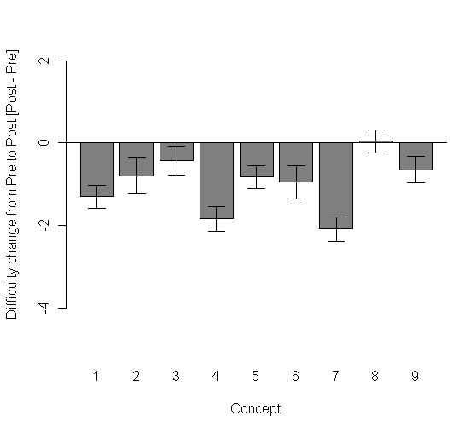
Figure 8. Change in Pre to Post tests difficulty for each concept.

