Manohar Arora is a Teaching Professor at Colorado School of Mines, Golden, CO. He teaches Engineering Mechanics and graduate courses in advanced structural analysis. He received B.S. in Civil Engineering from University of Roorkee (India) in 1962, M.S. in Structural Engineering in 1967 and Ph.D in Engineering Science from University of Mississippi in 1972. He is a retired aerospace engineer from Lockheed Martin where he worked on the structural dynamics analysis of space launch vehicles. His previous work includes structural analysis and design of Petro-Chemical plants. He is a registered Professional Engineer and member of Chi Epsilon (Civil Engineering Society).
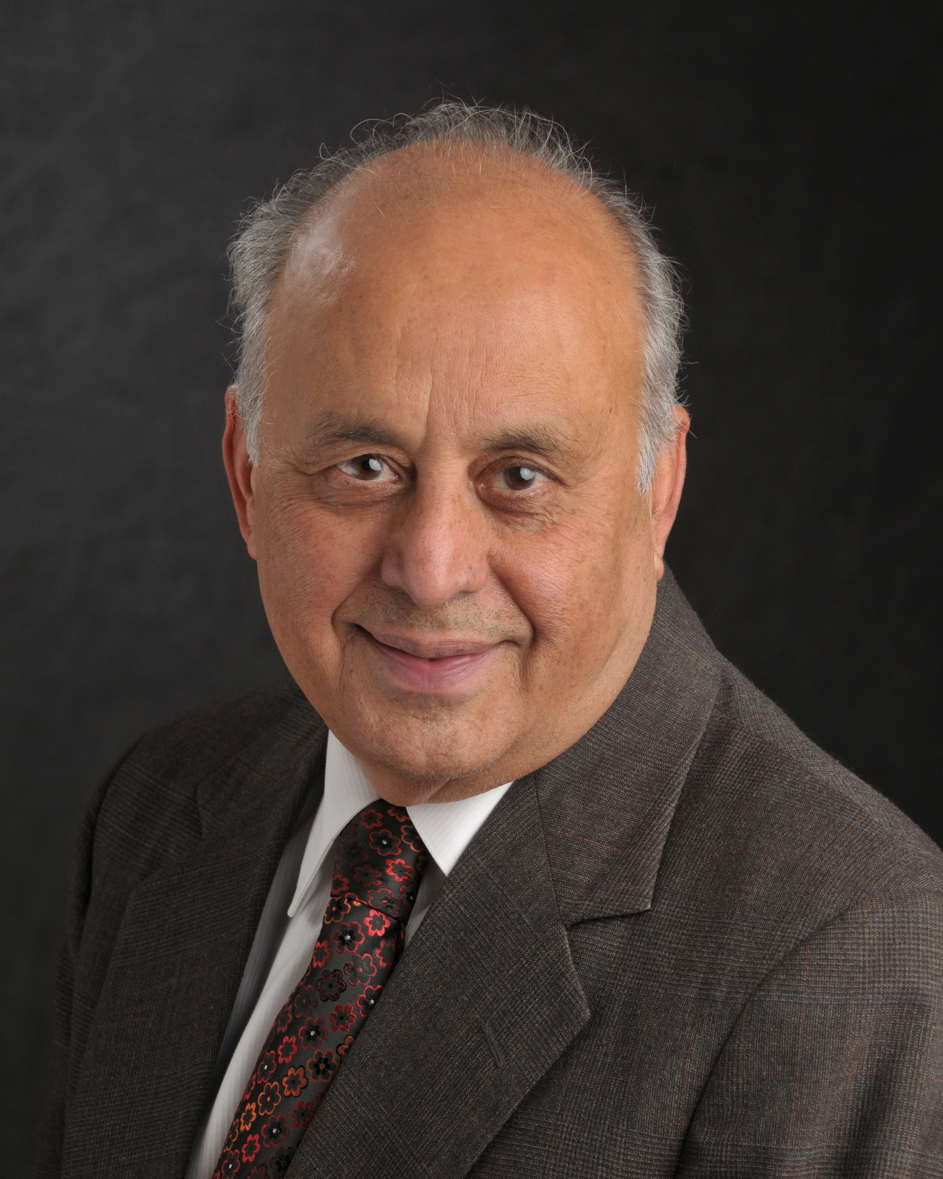

PhD. Associate Professor of Mathematics Education at Texas A & M

